**Angular Framework**

Angular is completely rewritten framework after angular 1.x. From Angular 2.0 we the framework is branded as angular 4.0.

Angular is one of the most widely acclaimed and popular client side framework which is best suitable for developing single page applications.

An Angular application uses typescript as scripting language. Typescript knowledge helps the programmers to quickly get started with Angular 2

**Component**

Component is basic building of angular application. In other words, Angular application is a collection of components. A component typically has a template(html) , Style(css), Data and functionalities (wrapped in a typescript class) associated with it. In Angular a component is a typescript class where it is qualified by a decorator @component which provides meta data about the component. The decorator has properties to specify Template, Style and selector for it.

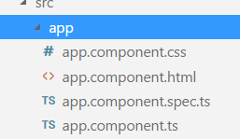

By default, In the app generated by angular CLI, the root component is created with name AppComponent. A html file and css file is generated to maintain template and style associated with it.

A component is a Typescript class with a decorator called @Component as shown below

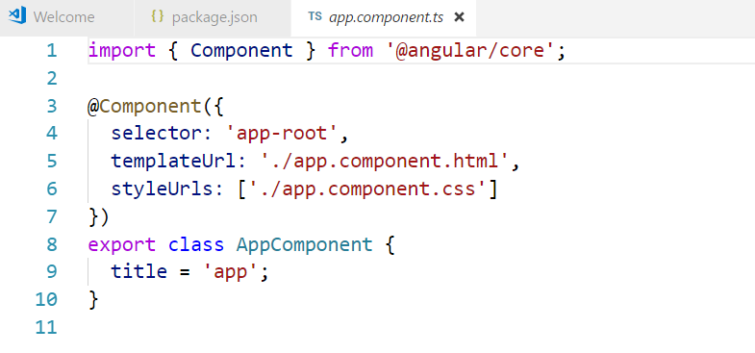

In the app.component.html file we refer to title variable by using the symbol {{ }}

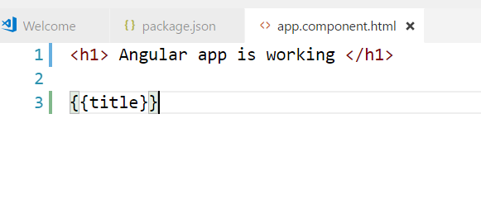

In the app.component.css file we styled the h1 tag

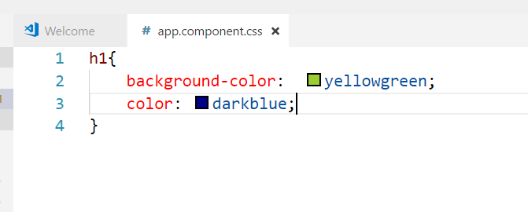

Bootstrapping your application

Every angular application is called a module. An Angular module is also a typescript class. All the components, pipes, directives and services which you create as part of your app come under a module. The module is generally configured under a file called (app.module.ts). A module is decorated with a decorator called @NgModule which has properties like declarations, imports, providers and bootstrap.

We use declarations property to specify your components, directives and pipes. We use imports to specify module imports and providers to specify services. The property called bootstrap is used to mention the root component of your app. There can more than one root component also for your app

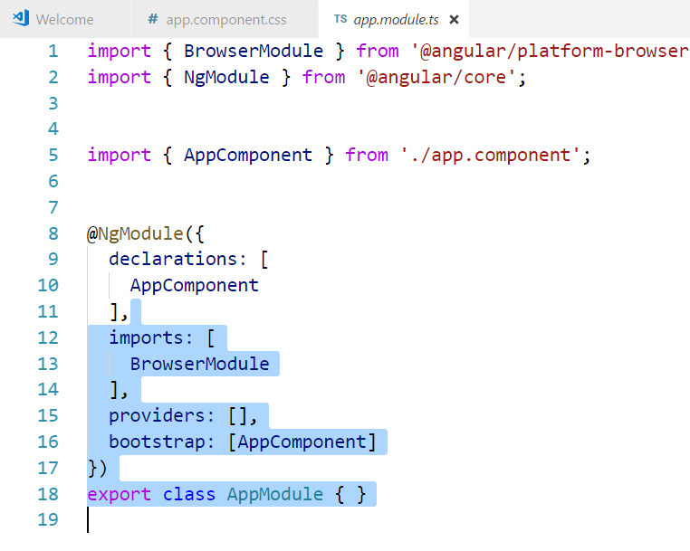

During development phase, angular CLI lets you run a development server and run your application . To compile your typescript, bundle and run your app, you must be running the command

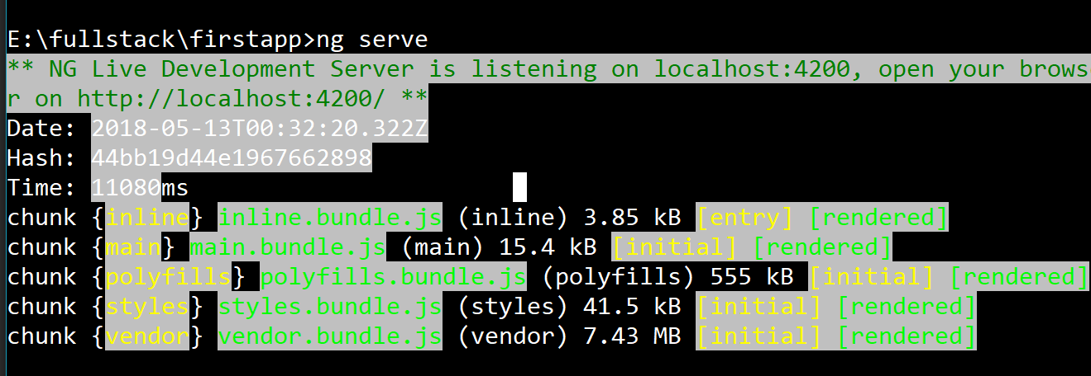

When you open the url in the browser, <http://locahost:4200>

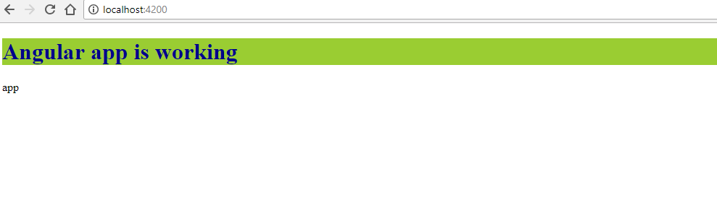

When you have look at the source code in the browser, you find the component should have been called by using the selector <app-root>

